1) When asked for Commercial plots, it is asking for how many bedroom, bathrooms would you like.
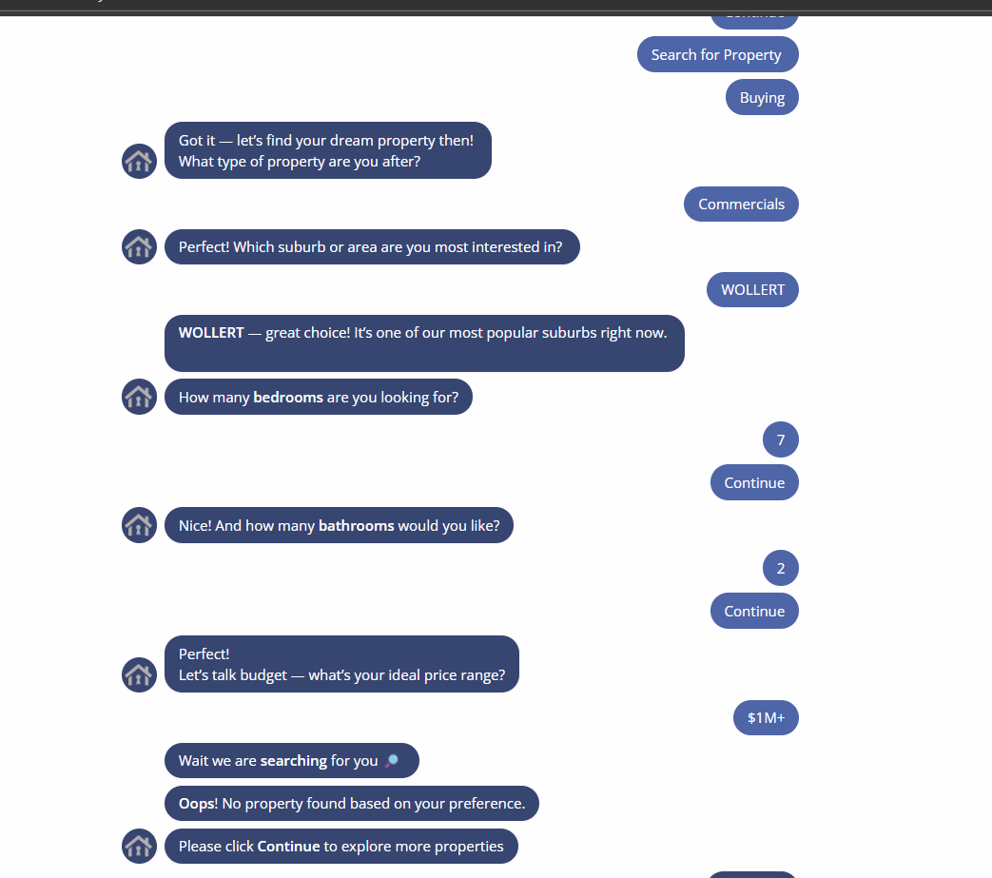

2) The chatbot’s location input field does not respond when a user types a suburb name and presses Enter, preventing the search from proceeding. Additionally, there is no search icon or auto-suggestion feature to help users select or confirm a valid location.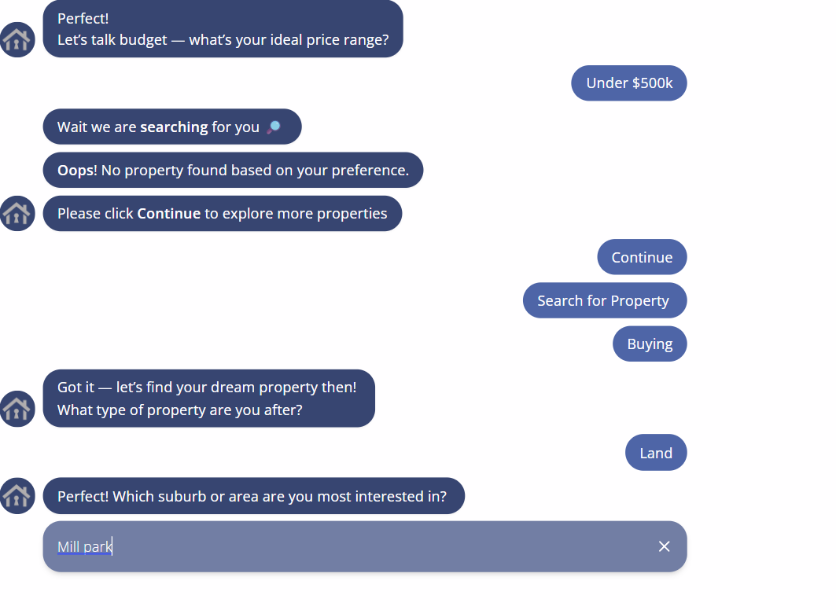

3) The chatbot accepts invalid phone numbers, such as those with 12 digits, without any validation.
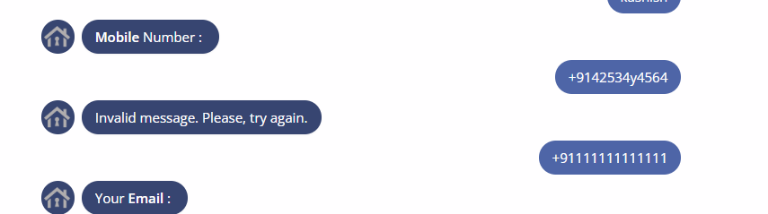

4) Invalid Input Acceptance (Property Address,Reason for selling?)
No Data Validation for Numeric Fields (Beds, Baths, Car Parks):
- The bot accepts numeric inputs but does not check for valid range or realistic limits (e.g., negative values, excessive numbers).

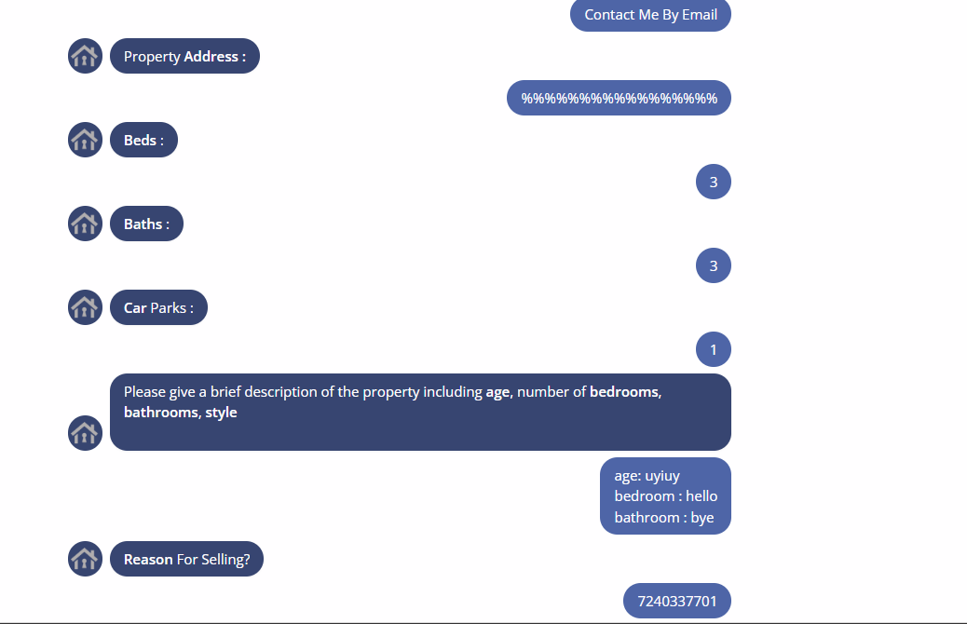

5) Selected country code from dropdown while entering mobile number:
Dropdown displayed only the selected item (highlighted in grey) while the rest of the list appeared white or invisible